5 FREE REGISTRATIONS
for

ESVS 2022
20-23 September 2022
In Rome, Italy

The Institute of Vascular Diseases (IVD) is offering five (5) in person free registrations (registration, flights, accommodation, ground transportation) to attend the ESVS 2022, 20-23 September 2022, Rome, Italy.
For more information about the event, please visit https://esvs.org/events/annual-meeting/esvs-annual-meeting-2022/
To claim free registration, you can be a resident surgeon or qualified physician.
You are kindly requested to send an email to ivd.contactus@gmail.com with the following information: full name, profession, medical facility, email, telephone number, address.
The e-mail should be sent by 17:00p.m, on September 16th, 2022 at the latest.
Registrations will be handled on a first-come first-served basis and successful candidates will be informed via email on September 17th, 2022, by 14:30p.m.
On behalf of IVD,
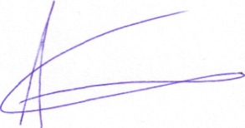
Prof. Athanasios Giannoukas

