3 FREE REGISTRATIONS
for

70th ESCVS Congress/ 7th IMAD 2022
20-23 June 2022
In person

The Institute of Vascular Diseases (IVD) is offering three (3) in person free registrations (registration, flights, accommodation) to attend 70th ESCVS Congress & 7th IMAD Meeting Liege Belgium 20-23/06/2022. For more information, please visit https://escvs2022.com/
To claim free registration, you can be a qualified intern, resident surgeon or qualified physician.
You are kindly requested to send an email to ivd.contactus@gmail.com with the following information: full name, profession, medical facility, email, telephone number, address.
The e-mail should be sent by 17.00 pm, on June 7th, 2022 at the latest.
Registrations will be handled on a first-come first-served basis and successful candidates will be informed via email on 8th of June 2022, by 14:30p.m.
On behalf of IVD,
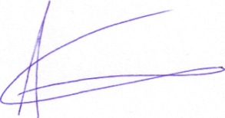
Prof. Athanasios Giannoukas

